# How To Clone a Git Repository

Go to Azure Repos page

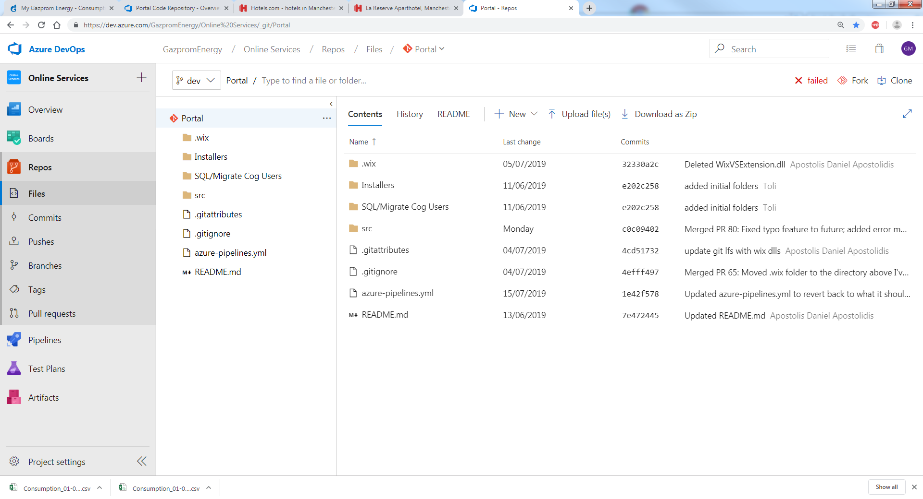

Click on Drop Down arrow on the last part of the currently selected repository.

Click on New Repository

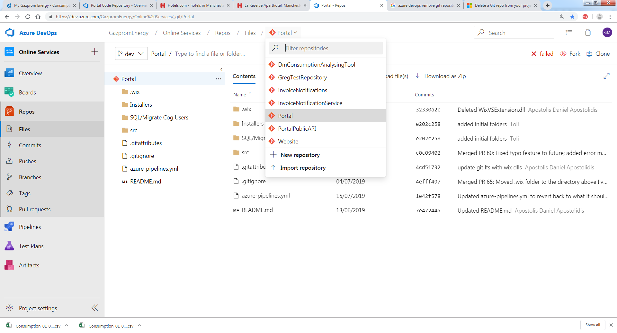

Give your repository a name and click on Create

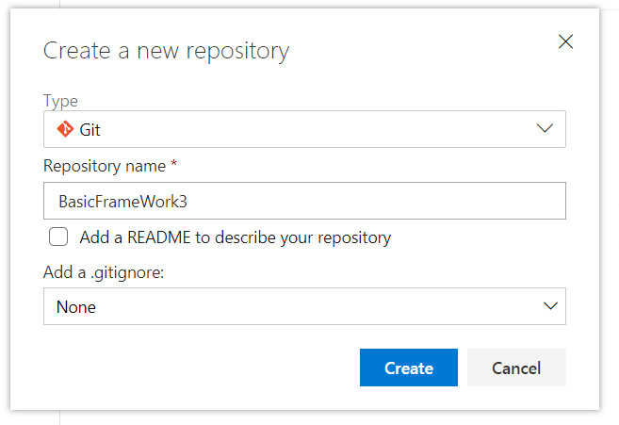

Once your repository has been created, copy the URL from the ‘Clone to your computer’ section on the screen (see screen shot below).

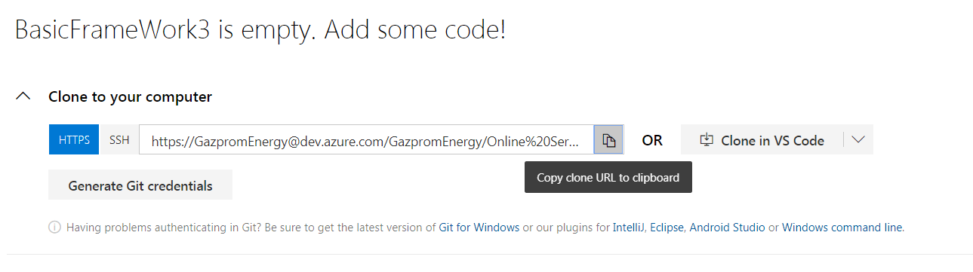

Open Windows File Explorer

Navigate to folder containing your Repos

Right click and select Git Bash Here

This will open up a Git Bash command window

Type the following: (path is what you copied earlier, right click to paste it)

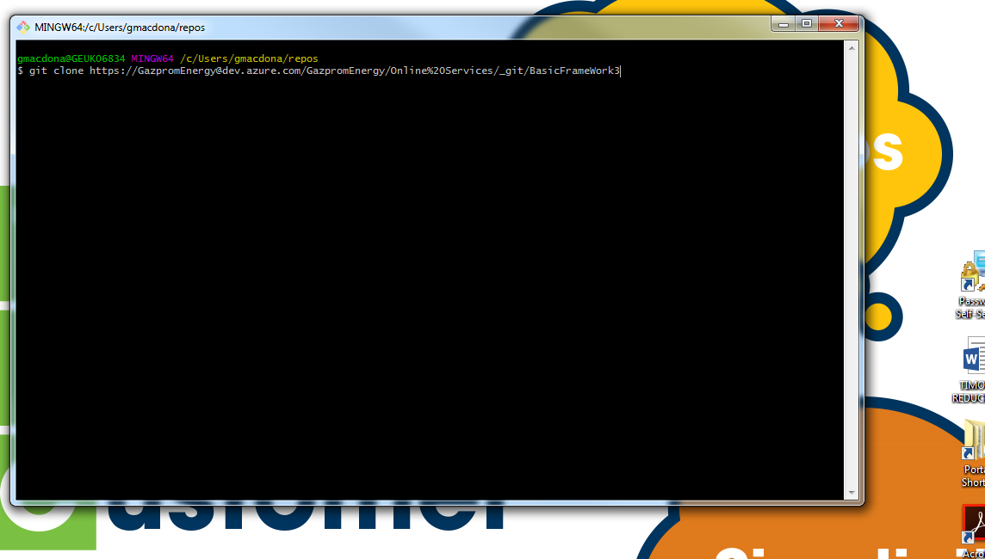

Press Enter and a your new repostitory will be cloned (mapped)

Don’t worry about warning message saying you have cloned an empy repository

# Creating Project (with solution) in Git Repository

In VS select File New-> Project

Give Poject a name. By default Solution will have same name, you can change it if you want to.

Be sure to select the correct type of project, e.g. MSTest Test Project (.NET Core) , UnitTest Project (.NET Framework) etc.

Untick Create new Git repository.

Click on Browse

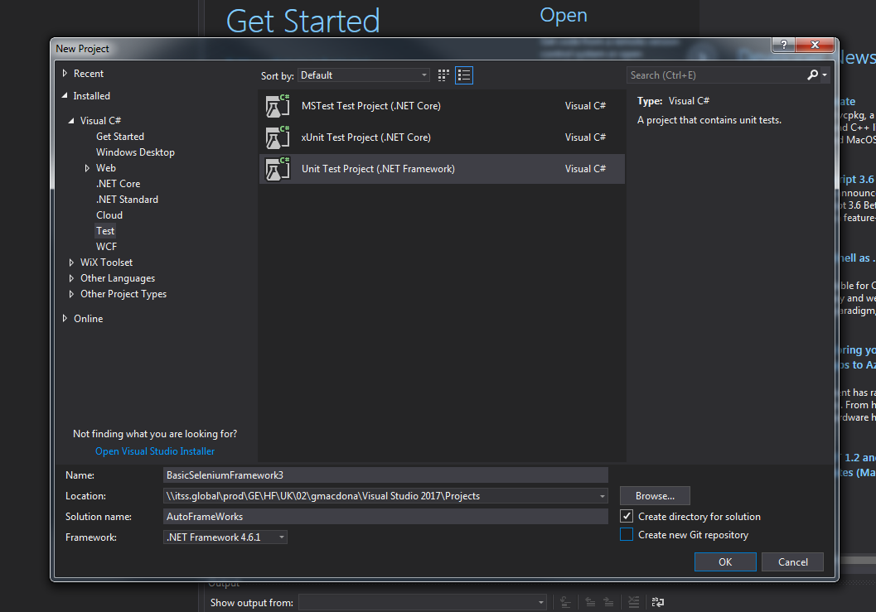

Select your repository, open it and click on Select Folder

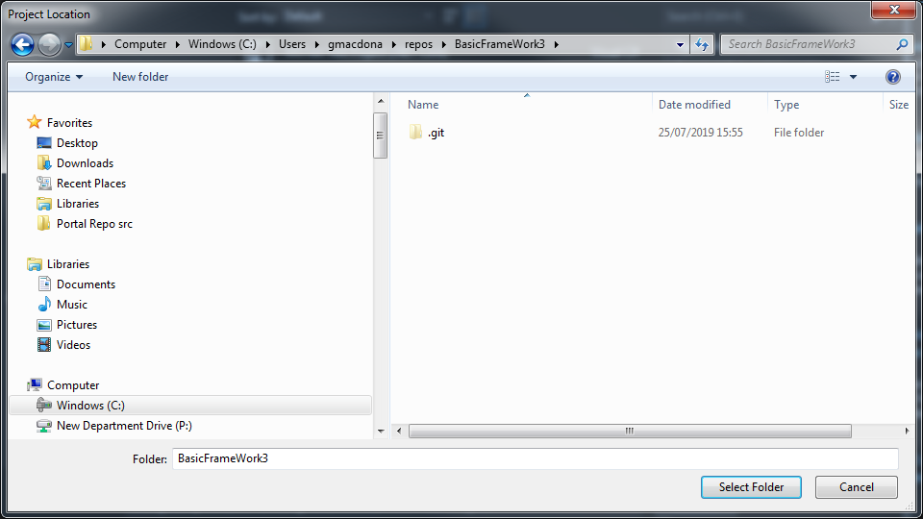

Click on OK in the New Project window in Visual Studio.